# Brain Storm for BillyCam

Created by: Nemo

Ver: 0.1

# Only solid foundation can contribute skyscrapers

### My brain storming begins from the bottom to the top.

|  |  |  |  |  |
| --- | --- | --- | --- | --- |
| **Hardware requirements** | | | | |
| Modules  Requirements | CPU module | Camera module | Communication module | Voice module7 |
| R1 | ARM architecture | Multi-lens2 | nX5G/6G5 |  |
| R2 | Multi-core1 | Wide-angle lens3 | Underwater acoustic communication6 |  |
| R3 |  | Motion capture lens4 |  |  |

|  |  |  |  |
| --- | --- | --- | --- |
| Modules  Requirements | Tripod Heads | Interface for drone8 | Power module9 |

1, Every core is responsible for one lens under HDTV video/Ultra HD video processing.

2, Multi-lens make picture-in-picture/VR possible.( Scalable & Replaceable with front-projected holographic display module).

3, Make panoramic view possible.

4, Make target motion capture possible.

5, Make communication/data relay between devices possible.

6, Make live broadcast of underwater world; curious spectacle in the ocean; submarine accident possible.

Waterproof IPX8 at least.

7, Camera&voice as input interface during setup.

8, Make 7x24 live broadcast of regional hot spot from the sky possible. Such as Israeli–Palestinian conflict.

9, Solar charging/nuclear battery.

|  |  |  |  |  |
| --- | --- | --- | --- | --- |
| **Firmware options** | | | | |
| OS  App | Bootloader+  ucLinux | MicroC/OS-II / MicroC/OS-III + uC/TCP-IP | FreeRTOS | RTLinux |
| RTSP Server |  |  |  |  |
| SSH server1 |  |  |  |  |
| FTP server2 |  |  |  |  |
| P2P |  |  |  |  |
| DHCP3 |  |  |  |  |

1, For debugging.

2, For debugging.

3, For debugging.

Reference links:

https://en.wikipedia.org/wiki/Comparison_of_real-time_operating_systems

https://github.com/TheCrypt0/yi-hack-v4

|  |  |  |  |
| --- | --- | --- | --- |
| **Web application options** | | | |
| Front-end  Back-end | React+  Redux | Vue | Django1 |
| Node.js |  |  |
| MongoDB |  |  |

Note：

1, Django is based on Python. Python is the basis of AI. Save lots of time on AI design.

2, P2P network service. The more people use BillyCam the more smooth of the user experience; save Infrastructure expenditure.

3, Any combination of front-end, back-end and database can be available. Just need to figure out the best combination.

|  |  |  |
| --- | --- | --- |
| **Mobile application** | | |
| OS  Function | Android | Apple |
| Login/Logoff |  |  |
| Settings |  |  |
| Live broadcast |  |  |
| Cast1 |  |  |
| … |  |  |

1, refer to Chromecast.

Application 1/n:

Pool game.

Application 2/n:

Football game(such as Serie A TIM).

How many possible users? Maybe several hundred thousand.

Application 3/n:

US will declassify UFO next month.

According to the 9th prophecies of Hopi(the oldest nation on the earth. Their 8 prophecies have been verified.), the blue catastrophic comet – Kachina will come in 2024. If BillyCam can live broadcast the astronomical event.

How many possible users? Should be several ten million.

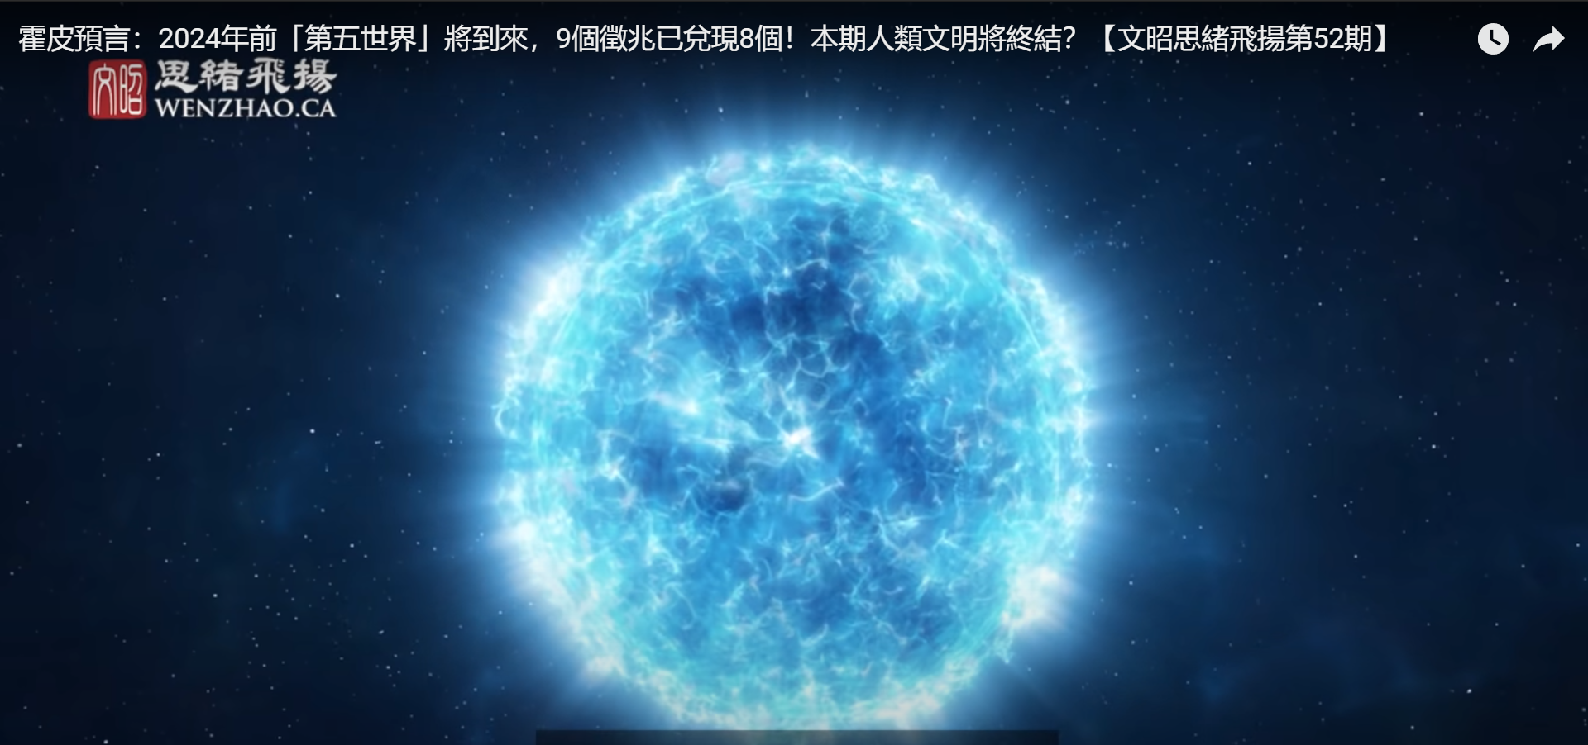

Application 4/n:

A bunch of devices spread evenly on the surface of moon. Set base station on the side which face to earth. Base stations can communication with any of camera through data relay. Base station communicates with space station or ground data receive/transmit center. Live broadcast any corner on the moon.

And if devices can be leased/controlled by individual(an ad slogan says “Extend your vision to the moon”).

What will happen? How many possible users? Should be several billion.

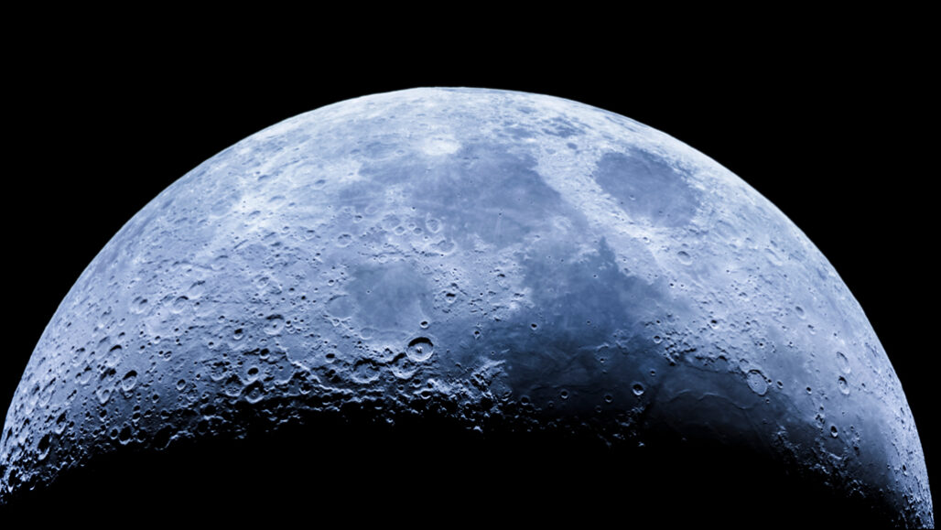

**Possibility**

How much transmit power needed?

Refer to Starlink. And the distance difference between Starlink’s satellite/ground device and moon/space station(earth). Adjust the transmit power correspondingly.

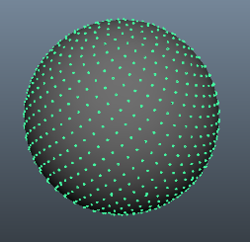

How many devices needed?

According to the diameter of the moon - 3500km and signal coverage range of a single device. It can be easily calculated.

Application 5/n:

Copy application 4 to Mercury, Venus, Mars… Saturn

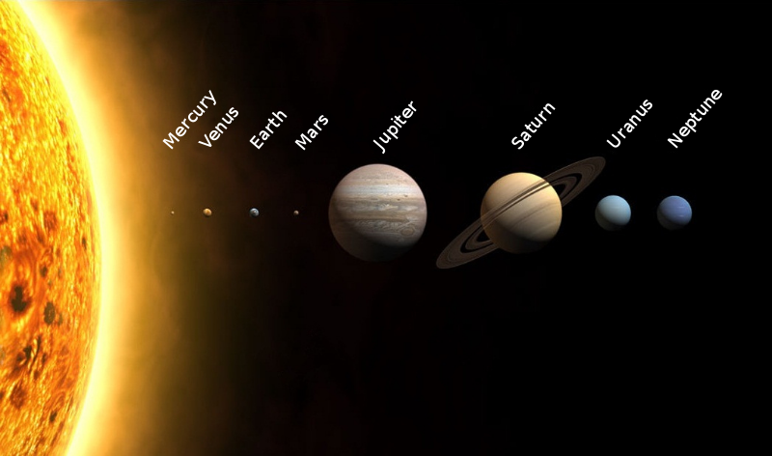

How many possible users? several ten billion people.

What’s the benefit if monthly member fee is 10? How about 20, 30….

When we go to here. What does it mean to BillyCam(I would suggest a cool name: SkyEye)

**A 2nd NASA, but more successful.**

**Now, the first thing BillyCam can do is registering domain SkyEyeI, SkyEyeII, SkyEyeIII, SkyEyeIV……**